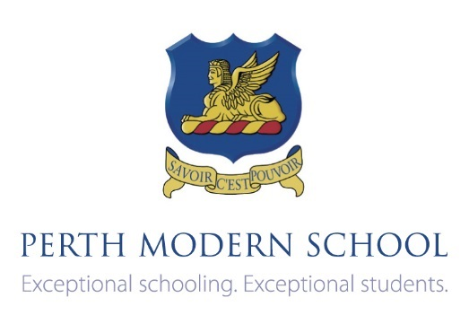**Test 1**

**Differentiaton , applications and Optimisation.**

Basic antidifferentiation

## Semester One 2018 Year 12 Mathematics Methods

**Calculator Free**

**Date: Friday 16th February 7.45am**

**You may have a formula sheet for this section of the test.**

**Total___________/21 20 Minutes**

**Question 1 (3 marks)**

Given that the function $f$ has a rule of the form $f\left(x\right)=ax^{2}+bx$ and $f\left(1\right)=6$ and $f^{'}\left(1\right)=0$, find the values of $a$ and $b$.

**Question 2 (8 marks)**

Consider the gradient function $f^{'}\left(x\right)=12({x+2)}^{2}\left(x+5\right).$

(a) Graph the gradient function (4 marks)



(b) What kind of feature is at the point $(-5, -225)$ on the graph of $f\left(x\right)?$ (2 marks)

(c) What kind of feature is at the point $(-2, -144)$ on the graph of $f\left(x\right)?$ (2 marks)

**Question 3 (6 marks)**

Clearly showing your use of the product, quotient or chain rule differentiate the following.

*(YOU MAY LEAVE YOUR ANSWERS IN UNSIMPLIFIED FORM)*

1. $10p({1-p)}^{9}$ (2 marks)
2. $\frac{1}{\sqrt{x+2}}$ (1 marks)
3. Consider the function $f\left(x\right)={\left(x-1\right)}^{2}\left(x-2\right)+1$ (3 marks)

If $f^{'}\left(x\right)=\left(x-1\right)\left(ux+v\right),$ where $u$ and $v$ are constants, use calculus to find the

values of $u$ and $v.$

**Question 4 (4 marks)**

The time $T$ seconds, for one complete swing of a pendulum of length $l m,$ is given by the rule $T=2π\sqrt{\frac{l}{g}}$, where $g$ is a constant.

(a) Determine $\frac{dT}{dl}$, (2 marks)

(b) Using the formula $∂T≈\frac{dT}{dl}$ x $∂l,$ find the approximate increase in $T$ when $l$ is increased from 1.6 to 1.7. Give the answer in terms of $g.$ (2 marks)

Test 1

Differentiaton , applications and Optimisation.

Basic antidifferentiation

## Semester One 2018 Year 12 Mathematics Methods

**Calculator Assumed**

**Date: Friday 16th February 7.45am**

**You may have**

* **a formula sheet**
* **one page of A4 notes, one side**
* **a scientific calculator**
* **a Classpad**

**Total_____________/25 25 minutes**

Question 1 (9 marks)

A model train travels on a straight track such that its acceleration after $t$ seconds is given by

$a\left(t\right)=pt-13cm/s^{2}$, $0≤t≤10$, where $p$ is a constant.

(a) Determine the initial acceleration of the model train. (1 mark)

The model train has an initial velocity of $5cm/s$. After 2 seconds, it has a displacement of $-50cm.$

A further $4$ seconds later its displacement is $178$ cm.

(b) Determine the value of the constant $p.$ (4 marks)

(c) When is the model train at rest? (2 marks)

(d) How far did the model train travel in the 8th second. (2 marks)

**Question 2 (6 marks)**

A beverage company has decided to release a new product. “Modmash” is to be **sold** in $375 mL$ cans that are perfectly cylindrical. {Hint: $1mL=1cm^{3}$}

(a) If the cans have a base radius of $x cm$ show that the surface area of the can, $S,$ is given

by: $S=2πx^{2}$ + $\frac{750}{x}$. (2 marks)

(b) Using calculus methods, and showing full reasoning and justification, find the dimensions of the can that will minimise its surface area

(4 marks)

**Question 3 (10 marks)**

Let $f\left(x\right)=-(x+1)^{2}(x-3)$.

(a) Use calculus to locate and classify all the stationary points of $f(x)$ and find any points of inflection. (6 marks)

(b) On the axes provided sketch the graph of $f\left(x\right), -1≤x≤4,$ labelling all key features. (4 marks)